Executive Summary
Building A GIS Database for Shady Creek Forest Resources
By Austin Carey
Professional Science Master’s in Environmental Science
Environmental Science Graduate Program
Oregon State University
Winter 2026
Background
Shady Creek Forest Resources (SCFR) is a private forest ownership located just North of Walton, Oregon. The property has been owned and maintained by David Eisler (Dave) since the late 1970s. Throughout his years of ownership Dave has worked with many organizations to steward the property toward responsible forest management including the Oregon Department of Fish and Wildlife (ODFW), the Bureau of Land Management (BLM), and various watershed councils.
In addition to this work Dave has consistently practiced sustainable forest management on the property by periodically logging trees for the sake of promoting age and species diversity on the property. The lumber from this logging has been sold by Dave as SCFR’s primary source of revenue.
However, in recent years lumber sales have stagnated and in order to introduce a fresh perspective to the situation, Dave partnered with Oregon State University to open his land to research opportunities with the hope that this research would lead to more optimal protection of wildlife habitat, new forest management techniques, or avenues to bolster lumber sales.
As this was the first time any intern or researcher had worked with SCFR, it was important for a baseline to be established, so that future researchers might have data with which to ask critical questions. So, with that in mind the goal of this internship was to create a database consisting of publicly available datasets that would be useful to future researchers and useable by any who wished to do so.
Methods
Data was collected from publicly accessible websites and databases and refined using ArcGIS Pro. The refinement primarily consisted of clipping the expansive datasets to the boundary that was relevant to the project.
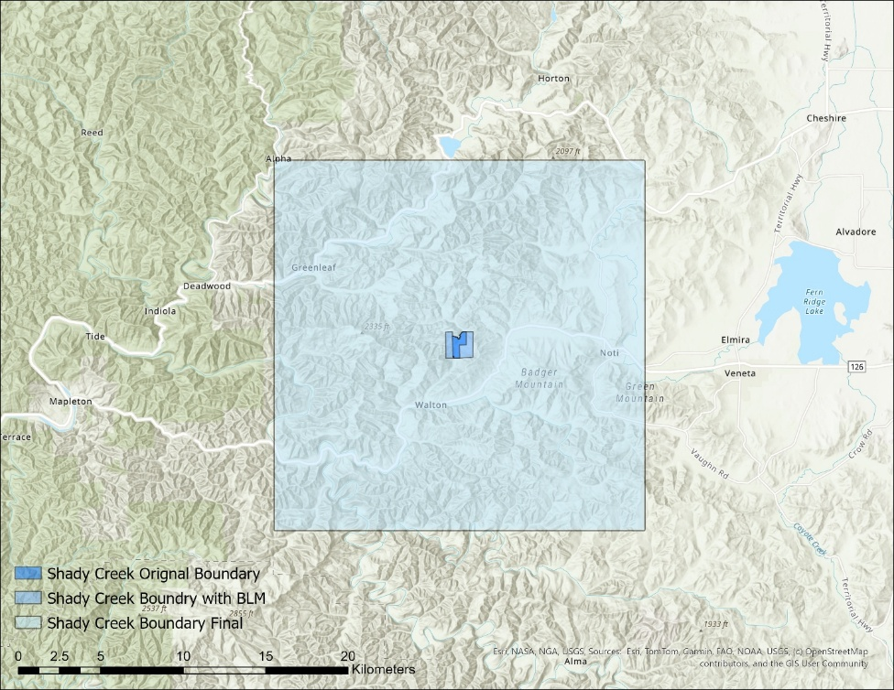
Figure 1: A map of all the relevant boundaries to the project
Figure 1 depicts the initial Shady Creek property boundary, and expanded boundary that included some adjacent parcels of BLM land, and finally a greatly expanded boundary that was deemed essential to producing quality data for the project. With a few exceptions, the final 500km^2 boundary was used for clipping all of the datasets collected.
In order to create this database, all of the collected data had to be clipped from sizes that sometimes included the entirety of North America. To do this, ArcGIS Pro’s Model Builder feature was used to clip the thousands of collected files in an efficient manner.
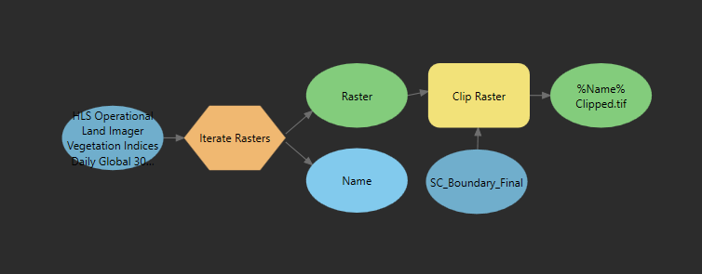
Figure 2: A model made using ArcGIS Pro's Model Builder
Various different models were used to accomplish this, depending on the format of the data that was being processed. Figure 2 depicts a model set up to clip raster data that was already in a digestible “.tif” format.
Results
In total, after many rounds of filtering, 43 total datasets were collected and processed for the database. These datasets were separated into different categories based on what they depicted, as shown in Figure 3. All of the data was stored on a cloud storage server provided by Oregon State.
Category | Datasets
Fire | 2
Wildlife and Ecology | 8
Historical | 2
Hydrological | 6
Topographic | 1
Forestry and Vegetation | 7
Climate | 3
Geologic | 4
Administrative and Infrastructure | 6
Satellite Imagery | 4
Total | 43
Figure 3: The data categories and the number of datasets in each
Many of the categories contain datasets that could make for interesting topics of research in the future, and several graphics were made to help summarize a few of them as part of the full internship report. Figure 4 is one such graphic that displays a breakdown of habitat types taken from an assessment of the entire state of Oregon by ODFW and Portland State University, clipped of course, within the area relevant to Shady Creek.
A modest amount of field data was also collected for the project, using a handheld GPS device to collect the coordinates of features of interest on the property. These features mostly consisted of micro-wetland habitats that would not have featured in any of the larger scale wetland data that was collected, as well as the locations of manmade structures such as small shelters or flying squirrel boxes.

Figure 4: A breakdown of the habitats present within the Shady Creek area

Discussion
The data collected for this project presents many opportunities for future research on the property. For example, while some data was collected regarding the species that should or could call Shady Creek home, this data only contained information regarding amphibian and mammal species. A more thorough catalogue of plants, insects, birds, fish, fungi, etc. could be done in the area to get a more complete picture of the ecosystem. Additionally, data was collected regarding “degree-days”. This is a metric used to assess by how long and by how much a location has been above or below a certain temperature. This data could be helpful to future researchers in determining insect developmental schedules in the region, and could, in combination with other available datasets, lead to a thorough assessment of insect population health. There are many avenues to explore.
Marketing & Finance
SCFR takes a sustainable approach to lumber production that eschews the clear-cutting values of most large logging operations. In order to accomplish this Dave must be much more selective about the trees he logs. This means working at much smaller scales, with operating costs that are ultimately much higher per unit of labor than large logging companies. Despite this, Dave’s lumber still sells for much less than the lumber available from your local hardware store. And his sales are still in decline. According to Dave, this is mostly due to convenience. It’s much easier for customers to purchase from the hardware store than it is to drive out to Shady Creek and purchase lumber from Dave.
In order to address these issues, I would propose several potential solutions. Marketing encompasses the first couple of solutions as SCFR is just a small operation and the first step to increasing purchases is ensuring people are aware of its existence. This could be accomplished through social media and an informative website. This online presence could at the same time educate consumers as to the ethical and environmental benefits to Shady Creek’s style of lumber production.
Another potential solution could be found in the form of a slightly more involved plan to turn SCFR into a non-profit organization. This decision would allow the research, education, and business portions of this operation to work in concert. The extra money that SCFR generates could be used to fund future research. Researchers would then use what they learn to promote SCFR either scientifically or socially. This would in turn drive more business to SCFR and start the cycle over again, hopefully with time becoming self-sustaining.
References
Portland State University & ODFW. (2023a, June 16). Oregon statewide habitat map. Oregon GEOHub. https://geohub.oregon.gov/documents/894a627ba88b45b89d91ed37bc347365/about

