Final Project Executive Summary
The Monitoring Phase of the West Fontana Channel Habitat Restoration Project: Closing Out a Multi-Year Restoration Plan
Authored by Daniel Gonzalez for the degree of Professional Science Master (P.S.M.) in Environmental Sciences, Oregon State University, Presented March 11th, 2026
Graduate Advisor: Dr. Carolyn Fonyo
Graduate Committee: Dr. Ken Diebel, Dr. Bradley Barnhart
Abstract:
Cornerstone Development Company is a development and construction company based out of Victorville, with three subsidiaries, Cornerstone Construction Company, Cornerstone Utility Engineering, and Cornerstone Consulting Services. Cornerstone Consulting Services is the Subsidiary that focuses on environmental consulting and the intake of environmental analysis for utility construction projects. The goal and focus of Cornerstone Consulting Services is world change through environmental responsibility. The West Fontana Channel Improvement Project is a restoration project with the area is a narrow buffer zone spanning 1.51 acres that sits just north of the drainage channel and a rail line. The mitigation sites are intended to reduce noise from the rail, improve air quality along the channel, and provide a space for native flora and fauna in an otherwise industrial area. This site is surveyed quarterly by Cornerstone Consulting Services and adaptive management efforts are made based on the survey results. The initial goal of 70% native ground cover for all 5 sites within the mitigation area has already been met, and now the project is focused on continued monitoring of these sites. My role as the project biologist is to be involved in every step in the planning, performance, and reporting for site field visits. This includes producing the field day schedules, ensuring that all pre-visit site maintenance is performed and that all safety measures have been adequately set in place before site visits. During the field visit I am responsible for filling out all field survey safety forms, conducting the field survey, and ensuring all tasks are completed. Post field day I am responsible for compiling the data and pictures taken during the field day and consolidating them into the report that gets sent to the county. This report analysis 3 quarterly surveys and discusses recommendations made in 3 quarterly reports and the annual report. This project helped me develop project management skills, field leadership skills, and furthered my knowledge of ecological restoration. It also presented me with unique challenges related to the project and forced me to improve my problem-solving skills and strengthen my ability to communicate with stakeholders.

Background:
The West Fontana Channel mitigation monitoring area is an approximately 1.5-acre strip of land immediately north of the West Fontana Channel running east to west across the city of Fontana. The mitigation area sits on the western side of Fontana California, a suburban city in San Bernadino County that sits at the southeastern edge of the San Gabriel Mountain Range and the southwestern edge of the San Bernadino Mountains. The mitigation area is divided into 5 mitigation sites which are separated by a mixture or streets, and access roads.
Historically the region south of the San Gabriel Mountain Range and San Bernardino Mountain Range has dealt with major flash flooding issues (Modrick & Georgakakos, 2015). This is due to a combination of climatic factors, and the topographic characteristics of the region. Southern California is prone to severe drought which causes the soil to become dry and loose, Dry and loose soil has lower structural integrity and is more prone to run off. When rain does occur, the dry topsoil runs off. In relatively flat areas the impact of runoff is not significant, but much of Urban Los Angeles and San Bernadino counties sit at the base of the mountains.
To prevent significant damage from these flash floods, Los Angeles County and San Bernadino County Public works developed a massive network of flood control channels and flood catchment zones which span from. San Bernadino county alone has over 20,000 square miles of flood channels. These flood channels can be found in urban, suburban, industrial, and rural areas. A map of the Flood Channels within the city of Fontana can be seen below (Figure 1). They often have buffer areas surrounding them that are narrows strip of bare ground, which is exactly what the West Fontana Channel Habitat Mitigation and Monitoring area was at the inception of the project.
The initial goal of the West Fontana Channel Habitat Restoration Project is for the native vegetation cover to reach 60% by year 3 and 70% by year 5. 2025 marked the 5th year of the project’s lifespan, and at this point the goal of 70% native vegetation cover across all five Mitigations Sites has been met. Now the goal of the project is to monitor the sites and ensure that the native plants remain healthy and maintain the 70% native vegetation cover threshold. Pictures of all 5 sites included in Figure 2. In order to remain in line with the standard structure of Oregon State University ESGP internship projects, this project has two major research questions. The first research question is, can the West Fontana Channel Habitat Restoration Project achieve its five-year goal of over 70% native vegetation cover. The second research question is, is this project effective at restoring the sight and could it be improved to be more effective.

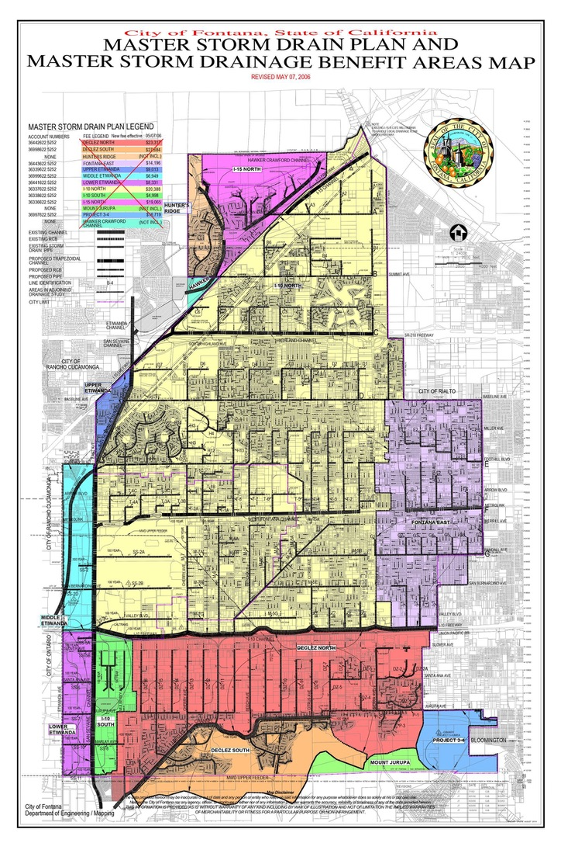
Figure 1. Map of all Storm Drain Flood Infrastructure in Fontana California. The West Fontana Channel can be seen in the middle of the yellow section (1-10 North). This Image was taken from the City of Fontana Webpage.

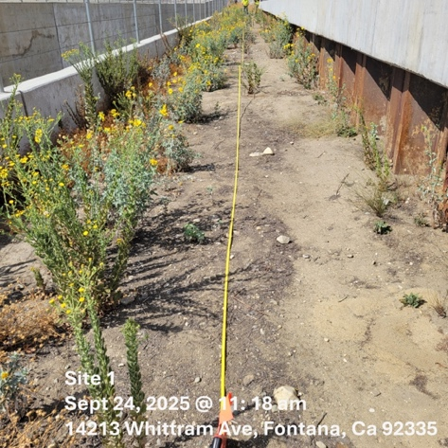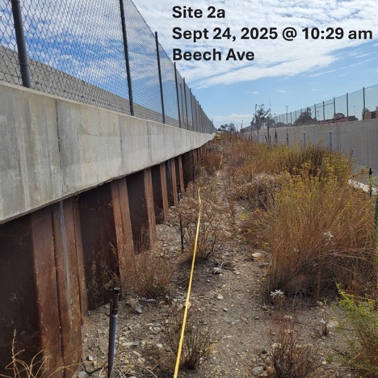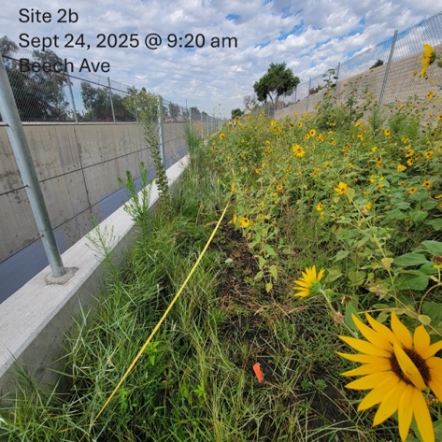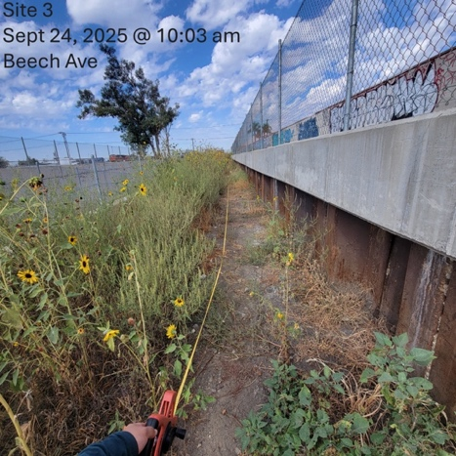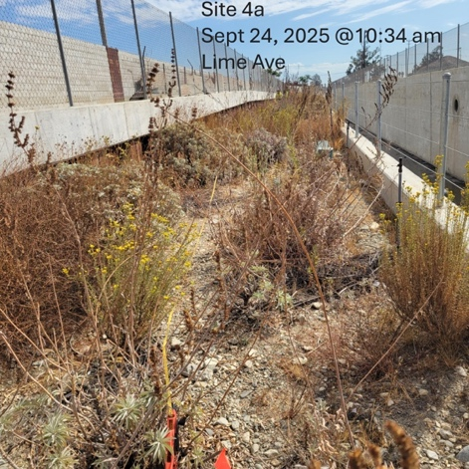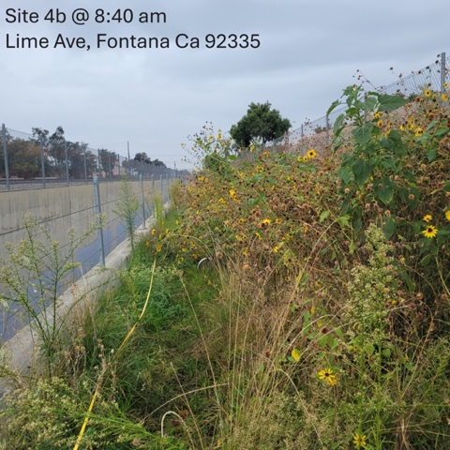
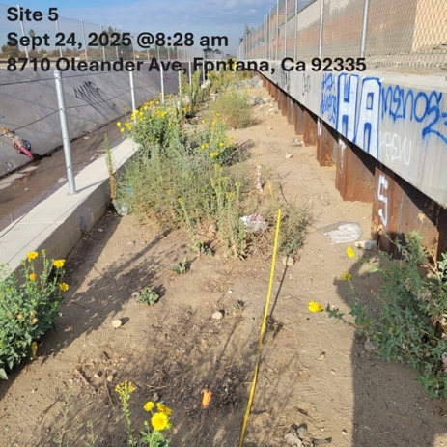
Figure 2. Photos of the Starting Point Each Survey Transect. These Starting points are the edge of the transect closest to the entrance to the Mitigation site. For the mitigation sites with two transects, they are labeled “A” and “B”. These labels are assigned based on distance from where the field crew enters the site. All photos are dated, and timed. These photos were captured by CCS Biologist Esmeralda Soto.
Methods:
Native vegetation cover is measured using a randomized point intercept methodology. After completion of the first round of planting 50 meter transects were established at random to give an estimated value for overall native vegetation cover. For the mitigation sites smaller than 1,500 square meters, only one 50-meter transect was measured. For the mitigation sites larger than 1,500 square meters, two 50-meter transects were measured. Every 5 meters along each transect, the ground cover species was identified, and the height of the vegetation was measured.
Upon determining the species found at each point along the transect, biologists identify them as either native species or nonnative/invasive. This information is used to calculate the native ground cover percentage, nonnative ground cover percentage, and percentage bare ground. Additional ecosystem health data is collected at each site prior to the survey in order to provide more context as to the overall quality of the site at the time of the site visit. This data includes, time of day, temperature, windspeed, wildlife observed, and signs of wildlife. “Wildlife observed” refers to biologists in the field actively observing individual(s) of a species, while “Signs of wildlife” refers to biologists encountering indications that a species utilizes the area but is not currently present.
All collected data is used to determine overall site health. Each mitigation site is then assigned a vegetation health condition classification. Criteria for the vegetation health condition was established by San Bernadino County at the beginning of the project and is listed below (Table 1.).
Vegetation Health Condition Classification | Criteria
- Excellent | ≤25% of individuals in the parcel are affected by signs of stress including poor hydration and/or severe insect predation. Few patches of bare ground, dead/dying container plants, and/or invasive plant species are present.
- Good | 25% to 50% of individuals in the parcel were affected by signs of stress, including poor hydration and/or severe insect predation. Minimal amounts of bare ground, dead/dying container plants, and/or invasive plant species are present.
- Fair | 50% to 75% of individuals in the parcel were affected by signs of stress including poor hydration and/or severe insect predation. Moderate sized patches of bare ground, dead/dying container plants, and/or invasive plant species are present.
- Poor | ≥75% of individuals in the parcel are dead or dying, with signs of stress such as poor hydration and/or severe insect predation. Large patches of bare ground, dead/dying container plants, and/or invasive plant species are present.
Table 2. The criteria for vegetation health condition. This criterion was established by the San Bernadino County Department of Public Works.
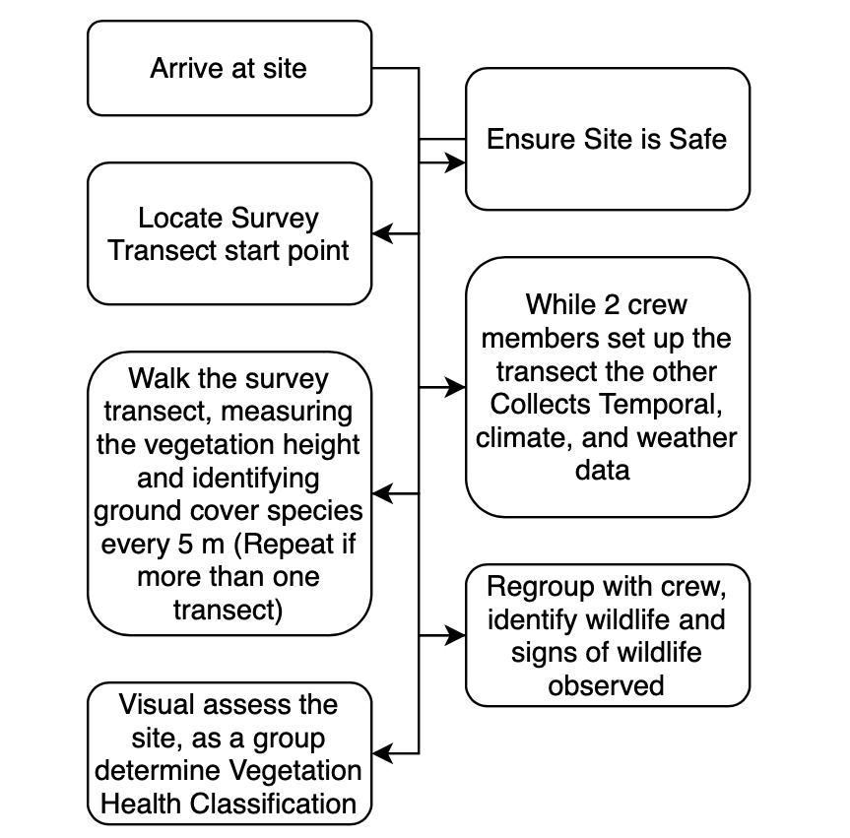
Figure 6. Survey Methodology Process Diagram.
Results:
Across all three surveys 4 of 5 sites maintained a percentage native plant cover above the 70% threshold required by the project. The Quarter 2 survey saw a native ground cover percentage of 80% in Mitigation Site 1, 90% in Mitigation site 2, 80% in Mitigation Site 3, 85% in Mitigation Site 4, and 60% in Mitigation Site 5. The average native ground cover for the Quarter 2 survey is 81.23% with a standard deviation of 10.69%. The Quarter 2 Survey technically occurred at the beginning of Quarter 3 (August 6th and 7th, 2025). This was requested by San Bernadino County due to a lack of a survey from April to July. All species observed in mitigation area are listed below (Table 5).
The Quarter 3 Survey saw a native ground cover of 80% in Mitigation Site 1, 100% in Mitigation Site 2, 80% in Mitigation Site 3, 85% in Mitigation site 4, and 60% in Mitigation Site 5. The average native ground cover for the Quarter 3 survey is 84.29% with a standard deviation of 13.97%. The native vegetation cover from for all 5 sites was consistent across Quarter 2 and Quarter 3.
Each Mitigation site received a vegetation health condition classification at the time of each field survey. This classification is decided based on factors of ecosystem health such as drought stress, heat stress, native vegetation abundance, vegetation height, and soil condition. Criteria for each of vegetation health condition classification is listed in Table 2. Mitigation site 1 received a grade of “Good” in Quarter 2, and “Excellent” in Quarter 3 and Quarter 4. Mitigation site 2 received a grade of “Excellent” across Quarter 2, Quarter 3, and Quarter 4. Mitigation site 3 received a grade of “Excellent” in Quarter 2, “Good” in Quarter 3, and “Excellent” in Quarter 4. Mitigation Site 4 received a grade of “Excellent” in Quarter 2, Quarter 3, and Quarter 4. Mitigation Site 5 received a grade of “Good” in Quarter 2, Quarter 3, and Quarter 4. This information is compiled and presented visually in Table 4.
Absolute Cover
Site 1 | Q2 | Q3 | Q4 | Average | Site 4 | Q2 | Q3 | Q4 | Average
Native | 0.8 | 0.8 | 0.8 | 0.8 | Native | 0.85 | 0.85 | 1 | 0.9
Invasive | 0.1 | 0 | 0.2 | 0.1 | Invasive | 0.05 | 0.05 | 0 | 0.033333
BG | 0.1 | 0.2 | 0 | 0.1 | BG | 0.1 | 0.1 | 0 | 0.066667
Site 2 | Q2 | Q3 | Q4 | Average | Site 5 | Q2 | Q3 | Q4 | Average
Native | 0.9 | 1 | 1 | 0.966667 | Native | 0.6 | 0.6 | 0.9 | 0.7
Invasive | 0.05 | 0 | 0 | 0.016667 | Invasive | 0.1 | 0.2 | 0 | 0.1
BG | 0.05 | 0 | 0 | 0.016667 | BG | 0.3 | 0.2 | 0.1 | 0.2
Site 3 | Q2 | Q3 | Q4 | Average | All Sites | Average | St Dev
Native | 0.8 | 0.8 | 1 | 0.866667 | Native | 0.846667 | 0.357408
Invasive | 0.2 | 0 | 0 | 0.066667 | Invasive | 0.063333 | 0.042709
BG | 0 | 0.2 | 0 | 0.066667 | BG | 0.09 | 0.071297
Table 3. Vegetation Cover across each of the 5 sites. Each color coordinated section includes the data from a different site. The last section includes compiled data across all sites. Important Note, the data is given in this table as decimals but presented as percentages in the remainder of the report. This is to give more exact numbers for the average and standard deviation calculations.
Flaws In study Design:
There are flaws in these metrics, which were established by the client prior to the internship period, and these numbers do not reflect the full story. Starting with Percent Native Ground Cover, only 10-20 data points were collected at each mitigation site. This is too small of sample size to accurately estimate ground cover or calculate an average for entire mitigation area. It also opens the door for outliers to have a significant impact on the data. For an example, in quarter 4 mitigation site 1 had two hits of Russian thistle on the transect, which is an invasive species here. There were less than 10 individual Russian thistles within site 1 but because 2 of them appeared on the transect the data would suggest that they made up 20% of the ground cover at the site.
Vegetation Health Classification Is also a flawed metric. This metric is arbitrary; it is not backed by data and is only based on visual inspection of the site. It’s not statistically derived which makes it difficult to accurately measure. Classification becomes something that is up to the interpretation of the surveyor. This creates issues when there on disagreements in interpretation. For example, After the Quarter 2 survey we initially classified mitigation site 5 as “Fair” rather than “good” due to a significant amount of bare ground along portions of the site that were not covered by the transect. The county’s biologist challenged this interpretation and said that based on our written description of the site we had no reason to classify it as “fair” and that it should instead be classified as “good”. I initially wanted to respond to the client defending my interpretation but was advised by my supervisor change my interpretation to agree with the client as it would help maintain client satisfaction.
Challenges Faced by the Project:
Summary of Challenges to the project
Major Safety Risks to field Crew | - Extreme heat during summer surveys  - Exposure to harmful substances
The Presence of Transients | - Damage to the site caused by the presence of transients  - Direct threats to the safety of the Field Crew  - Transients in the survey area forcing reschedule of survey.
Coordinating with Subcontractors | - Contractors unintentionally damaging the site by cutting back/removing native plants
Table 6. Summary of challenged CCS faced on the West Fontana Channel Habitat Restoration Project. In depth descriptions of these challenges can be found in the discussion section.
Summary and Conclusions:
The West Fontana Channel Habitat Restoration Project has approached its final stages. As the monitoring phase ends, the project has successfully reached the goal of 70% native vegetation ground cover across all five mitigation sites with an average 84.6667% across all three quarters. In addition, all sites maintained a vegetation health condition classification of “Good” or better with two of the five maintaining a classification of “excellent”.
According to the standards established by the client, San Bernadino County, the mitigation area would be considered restored. While this would allow San Bernadino County to halt all monitoring and move on to future projects, the biologists at CCS believe further surveys will be necessary. This is due to the high likely of future degradation caused by the site’s location along the flood channel, and its frequent utilization by transient individuals. Continued monitoring would significantly reduce degradation and prevent the need for future restoration efforts in the same area.

References:
City of Fontana. (2025). Master storm drainage plan. Master Storm Drainage Plan | Fontana, CA - Official Website. https://www.fontanaca.gov/3535/Master-Storm-Drainage-Plan
Falk, D. A., Palmer, M. A., & Zedler, J. B. (2006). Foundations of Restoration Ecology. Island Press.
Franklin, T. M., Helinski, R., & Manale, A. (2007, September). Fish and wildlife response to farm bill conservation practices 103. USDA FSA.Gov. https://www.fsa.usda.gov/Internet/FSA_File/chap_7.pdf
Griffith, G. E., Omernik, J. M., Smith, D. W., Cook, T. D., Tallyn, E., Moseley, K., & Johnson, C. B. (2016, February 23). Ecoregions of California. Open-File Report. https://doi.org/10.3133/ofr20161021
Indeed. (2026). Environmental consultant salary in California. Environmental Consultant Salaries, CA. https://www.indeed.com/career/environmental-consultant/salaries/CA

Modrick, T. M., & Georgakakos, K. P. (2015). The character and causes of flash flood occurrence changes in mountainous small basins of Southern California under projects Climate Change. Journal of Hydrology: Regional Studies, 3, 312-336 https://doi.org/10.1016/j.ejrh.2015.02.003
San Bernardino County. (2025) District zones. Public Works. https://dpw.sbcounty.gov/flood-control/district-zones/
Shaules, K., & Shaules, C. (2020). CORNERSTONEDC. CornerstoneDC. https://www.cornerstone.dev/
Van Bruggen, A. H. C., He, M. M., Shin, K., Mai, V., Jeong, K. C., Finckh, M. R., & Morris, J. G. (2018). Environmental and health effects of the herbicide glyphosate. Science of The Total Environment, 616–617, 255–268. https://doi.org/10.1016/j.scitotenv.2017.10.309
Zhou, W., & Beck, B. F. (2005). Roadway Construction in karst areas: Management of stormwater runoff and sinkhole risk assessment. Environmental Geology, 47(8), 1138–1149. https://doi.org/10.1007/s00254-005-1252-z

