Executive Summary of: Integrating Environmental Analysis into the LCC GIS Curriculum
By Laura Gregory
This project is a result of my time as an intern at Lane Community College (LCC) working with their Geographic Information Science (GIS) certificate program. Lane Community College is a publicly operated community college in Eugene, Oregon that provides accessible, affordable education through transfer programs, career-technical education (CTE), and certificate offerings. Its mission emphasizes “accessible, inclusive, learning-centered educational opportunities” that support equitable student success. Like many community colleges, LCC has experienced declining enrollment in recent years, prompting a strategic focus on program improvement and student success. This project contributed to these efforts, broadening and strengthening the GIS program curriculum by adding materials focused on analysis of remotely sensed imagery.
The main objective of this project was to improve the LCC GIS curriculum through the development of three remote sensing–based laboratory modules while also evaluating the program within a broader institutional and business context. These modules were developed based on program review recommendations to make course materials more spatially relevant through use of local data, expand student exposure to remotely sensed imagery, strengthen quantitative and analytical skills, especially related to environmental topics, and broaden the set of skills that students learn throughout the program. Each lab module introduces a remote sensing concept, strengthens spatial and critical thinking, and expands students’ technical and analytical skill set through hands-on, place-based learning centered on the Mount Hood region of Oregon. Overall, this internship project integrated curriculum development, environmental analysis, and program-level strategic considerations, contributing to both educational and organizational value at LCC.
Using Landsat imagery from 1994–2024, lab modules were developed to progressively build analytical skills in imagery and environmental analysis. Each lab includes background information on the lab topic, lab-level measurable student learning outcomes, step-by-step instructions for workflow, questions and calculations that lead students in critical thinking and additional quantitative analysis. Each lab also includes a grading rubric, which aligns with measurable course learning outcomes to aid in student learning assessment.
The change in Normalized Difference Vegetation Index (NDVI) analysis and lab module focused on how NDVI values changed between 1994 and 2024. Results indicated relatively stable vegetation conditions in the Mount Hood region, with only a small increase of 0.03 in average NDVI. An interactive web map (Figure 1) allows students to explore vegetation patterns for each year and the change over time, and interpret a raster-based environmental index.
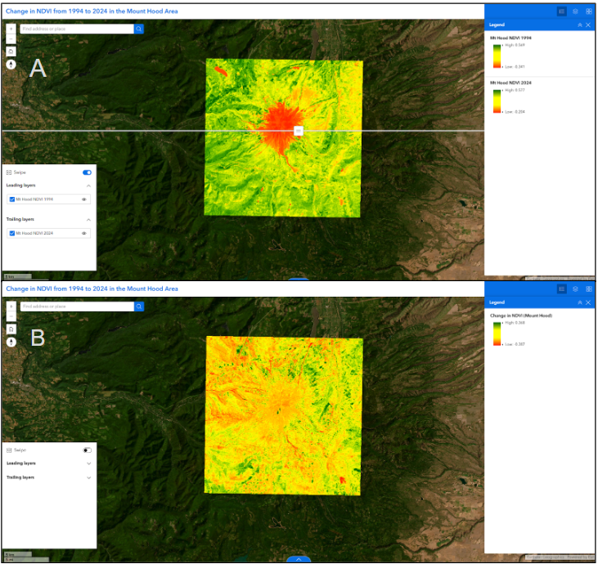
Figure 1. Screenshots of the NDVI web experience on ArcGIS Online showing (A) the swipe tool that allows for visual comparison of 1994 and 2024 data and (B) the change in NDVI layer.
The glacial retreat analysis applied the Normalized Difference Snow Index (NDSI) to imagery for 1994, 2009, and 2024 to extract glacial area and calculate the change over time. Results indicate a decrease in glacier coverage over time of about fifteen percent, with a larger decrease seen in the second half of the time period, suggesting an acceleration in the rate of change. For this lab, students will present these findings through a scientific poster product (Figure 2), showing key aspects of the analysis, including raster processing images, a map showing an overlay of extracted glacial extents, and a summary statement of the quantified environmental change.
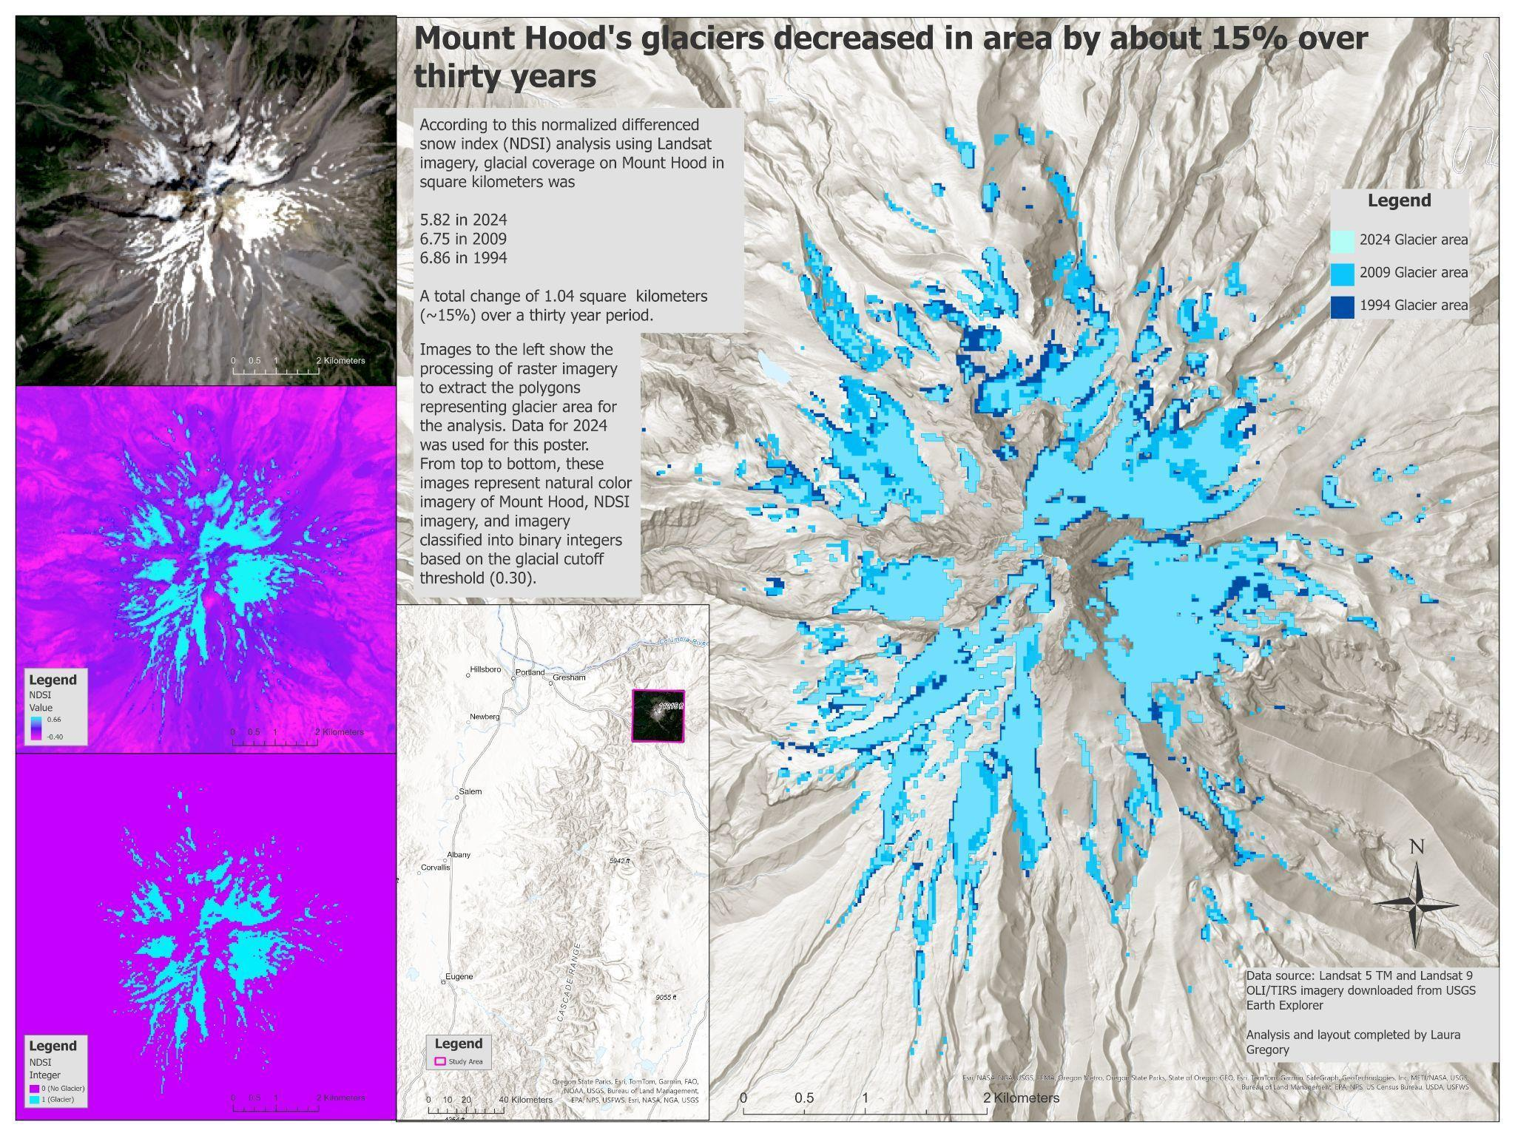
Figure 2. Example of what a student lab poster should look like for the glacial retreat module, including all required elements.
The burn severity analysis and lab module used differenced Normalized Burn Ratio (dNBR) to analyze the 2011 Dollar Lake fire. This analysis revealed that most of the study area (~86%) experienced low-severity burn, with limited high-severity impact, meaning that most of the ecosystem in the area of interest was impacted by the fire at a low severity level. For this lab, students will produce a scientific poster (Figure 3) that includes a map of the area of the fire visualizing the pattern of the fire using burn severity classifications, images of raster processing, and summarized results for the environmental analysis.
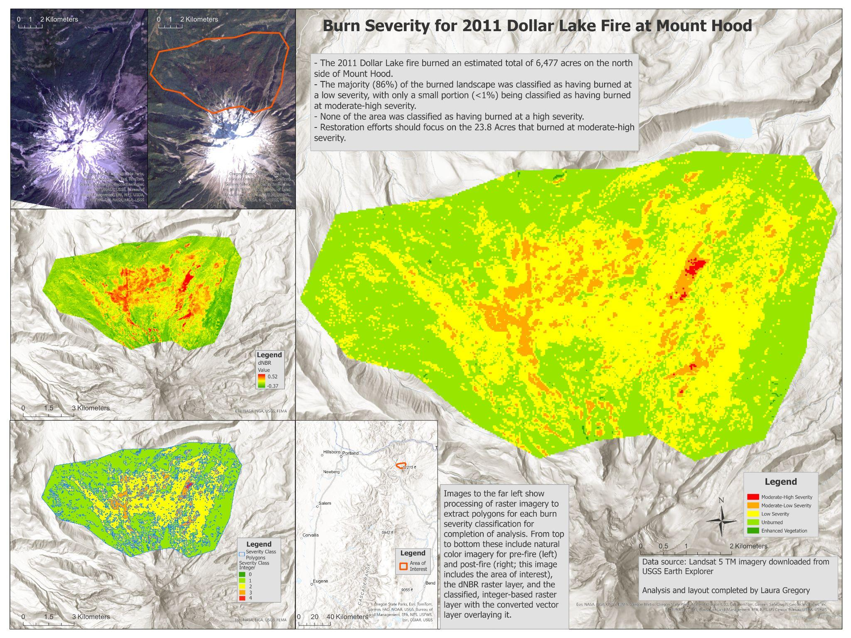
Figure 3. Example of what a student lab poster should look like for the burn severity module, including all required elements.
These lab modules enhance the GIS curriculum by providing hands-on experience with multispectral imagery analysis, environmental indices (NDVI, NDSI, NBR), raster analysis, and quantitative environmental analysis. In addition to technical skills, the modules promote critical thinking by requiring students to evaluate data limitations, interpret environmental change, and communicate results effectively. From a program perspective, this work supports LCC’s broader goals by improving curriculum relevance, broadening student skill development, and laying the groundwork for future course offerings in remote sensing.
Despite steady decline in LCC enrollment, the college generated enough revenue in 2024 to outweigh expenses, resulting in a positive net change in position for 2024. The GIS program contributes to institutional revenue, with an estimated program cost of about $2,342 per student. This project may even result in additional revenue for the college if a new remote sensing course is approved.
This project successfully integrated remote sensing into the LCC GIS curriculum through the development of three remote sensing-based environmental lab modules. The curriculum additions will broaden technical GIS training, incorporate locally-relevant environmental analyses, and support future program growth. Overall, this work demonstrates how curriculum development and changes based on program feedback can improve student learning outcomes and program sustainability.
Sources
Anderson, L. W., Krathwohl, D., R. 2001. A Taxonomy for Learning, Teaching, and Assessing: A Revision of Bloom’s Taxonomy of Educational Objectives. Langman.
Elwood, S. and Wilson, M. 2017. Critical GIS pedagogies beyond ‘Week 10: Ethics’. International Journal of Geographical Information Science, 31(10), 2098-2116. https://doi.org/10.1080/13658816.2017.1334892
Lane Community College. 2024. Annual Financial Report. Lane Community College. https://www.lanecc.edu/sites/default/files/2025-06/LCC%20Audit%20Report%20FY24.pdf
Lane Community College₁. Geographic Information Science, Certificate of Completion. Lane Community College. https://lanecc.smartcatalogiq.com/current/lcc-catalog/programs-of-study/social-science/geographic-information-science-certificate-of-completion/
Lane Community College₂. Strategic Plan. Lane Community College. https://www.lanecc.edu/about-lane/college-initiatives/strategic-plan
Lane Community College₃. Student Demographics and Enrollment. Lane Community College. https://inside.lanecc.edu/ir/student-demographics-and-enrollment
Lane Community College₄. Vision, Mission, and Values. Lane Community College. https://www.lanecc.edu/about-lane/vision-mission-and-values
McCullum, A., Beaudry, B., Torres-Perez, J., Cruz, S. 2023. Spectral Indices for Land and Aquatic Applications. Applied Remote Sensing Training Program - NASA. https://appliedsciences.nasa.gov/sites/default/files/2023-10/Spectral_Indices_Part1.pdf
Oregon State University. A Model of Learning Objectives. Oregon State University. https://ctl.oregonstate.edu/sites/ctl.oregonstate.edu/files/a_taxonomy_for_learning_teaching_and_assessing.pdf

